/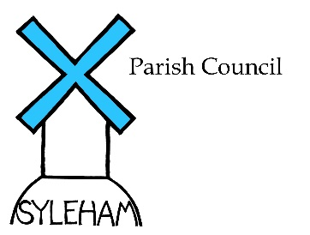Meetings May 25th, 2022
Annual General Meeting 21/22  Attendance:  Parish Councillors: M.Flounders; G. Elsden; G. Lewis; R. Piltch; S. Scott  S. Phillips & D. Goodwin  Absent: None  County & District Councillors: Lavinia Haddingham (MSDC)  Peter Gould (SCC) both attended  Other attendees: J. Thompson (Jubilee Coordinator) & M.Lewis (St Margarets)  Proceedings  - Chairman welcomed attendees  - Annual Reports were read out:  - Parish Council  - Village Hall/sports Club  - St Margarets  - MSDC &SCC reports were distributed before the meeting  Financial Audit for 2021/22 was presented by the Clerk and approved for sending to the external auditors.  Open Forum: An interest in a playground on J’s Meadow was raised and Councillor Lavinia Haddingham said she would do everything possible to help with MSDC funding  Scheduled Parish Meeting  Agenda  Declaration of Interest: None  Signing of Minutes: The minutes of the last meeting (May 2nd, 2021) were signed as correct.  Agenda Items:  - Platinum Jubilee  Julie Thompson gave an update on planning the June 5th celebrations  The Clerk gave a financial update, forecasting a potential £1000 underspend, monies that could be used in part funding the playground proposal  Planning:  - Monk’s Hall (DC/22/01698): This PA covered a proposed rear extension to the Hall. As the purported oldest house in Sufolk,  circa11th century, it is protected by numerous heritage agencies but the Council appreciated that making it fit for habitation in the 22nd century change has to happen. As the plans suggested no change to the appearance of the frontage then all the Council could do is remind Planning of its responsibilities of preserving the history of the building on the advice given by English Heritage etc  Clerk’s Report  - Finances: Current a/c balance @ April 5th 2022, was £5,370.34  and Business a/c: £975.43.  - Cheques for M. Flounders – Jubilee Oak Tree (#494-£50):  Party Packs- Cut out Queen (#495 -£41.94);TG Askew – plantings (#496- £660); Striptease – banner (#497-£72); Melanie Murray – paperware (#498- £242.66) Clerks Fee & Ex’s Q1 (#500-£326); HMRC-PAYE Q1 (#501- £48.00); J.Thompson -misc ex’s (#502-£ 195.20);E Carroll – Misc ex’s (#503-142.97); M.Flounders- Pavanni ice cream (#505-£251-35); Fox & Goose voucher -Thx to J.thompson (#506- £50); PHunter – Hog Roast (#507-£1400);M.Allmey website domain name renewal fee (#508-£11.99)Melanie Murray ink cartridges (#509 –£74.71) approved and signed.  Items in red relate to Jubilee expenses  Meeting closed at 8.25pm.  Next meeting takes place on September 21st ,2022 at the Village Hall.  Signed Date | Action  Clerk to action  Clerk to follow up  Clerk to write to MSDC

