/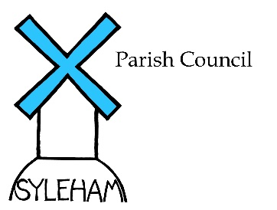Meeting March 2nd, 2022
Minutes  Attendance:  Parish Councillors: M.Flounders; G. Elsden; G. Lewis; R. Piltch; S. Scott  S. Phillips & D. Goodwin  Absent: G.Elsden & G Lewis sent their apologies  County & District Councillors:Lavinia Haddingham (MSDC)  Peter Gould (SCC) could not attend because of illness  Other attendees: J. McCraken (Curate), J. Thompson (Jubilee Coordinator) & M.Lewis (Village Hall)  Declaration of Interest: R Pilch (planning)  Signing of Minutes: The minutes of the last meeting (Dec !st, 2021) were signed as correct.  County & District Council Reports: These were distributed prior to the meeting and are attached to these minutes.  Agenda Items:  - Platinum Jubilee  Agreement to join forces with Wingfield PC and Village Hall in this celebration on June 5th was given the go ahead.  Proposal to donate £500 and purchase 32 commemorative mugs (£256) for village children was approved.  Plan to coordinate funding from all sources via PC bank account also agreed.  Village Hall balance from previous Jubilee (£464) was the first external donation accepted.  J. Thompson outlined the event and individual donations promised.  - Footpath Survey: Next steps  Proposal to send document to SCC for refurbishment of signage and reestablishment of rights of way was approved  3. Speed Sign  Rotation with Wingfield has taken place and acquisition of Syleham’s own sign awaits Wingfield’ s grant for a new one of their own  4. Dog Litter Bins  Purchase of third bin was approved when MSDC grant becomes available.  Planning:  - Border Piggeries (DC/22/01112), Hoxne Road – agricultural notification application was approved  Clerk’s Report  - Finances: Current a/c balance @ Feb 22nd 2022, was £5,855.25  and Business a/c: £975.41  - Cheques for Clerks fees & expenses Q4 (00491):£322.35: HMRC Q4 (00492):£120 and Jubilee Mugs (00492): £266.02  were approved and signed.  Other Business  The curate outlined the Church,s plan for a Ukranian Relief Appeal.  Meeting closed at 8.30pm.  Next meeting takes place on May 25th ,2022 at the Village Hall.  This will be preceded by the APM 2021/22 and starts at 7.30pm  Signed Date | Action  Clerk to action  Clerk to action  MF to action  Clerk to write to Planning

